TH1 Task Design Document

Approver | Signature | Date
Josh Jacobs | 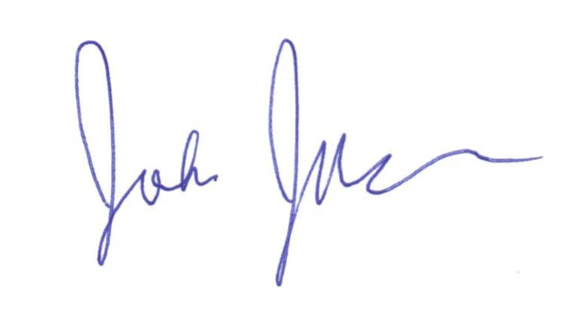 | 1/8/2016

Version | Author | Description | Date
1.0 | Corey Novich | First version | 1/8/2016
1.1 | Jonathan Miller | Modified confidence choice | 9/13/2017

The task is a paired associates task dealing in which a player must navigate a virtual environment with the use of a game controller. A full session of the task consists of 40 trial units, split up into 5 blocks of 8 trials each. When the player begins the game, they are greeted by a cartoon pirate welcoming them to the island. Then, they are shown two instruction screens -- the first, an overview of the task, and the second, a guide on how to choose recall responses to maximize their score based on their confidence. To continue past each screen, the player must press [X], and then they will move on to the trials.

At the start of each trial, the player is smoothly moved to one end of a rectangular field, situated in a colorful island environment. The player has a 50-50 random chance of being placed at either end. As they are moved, they are also rotated to face the center of the field. This movement and rotation will take between 1.5 and 3.75 seconds, depending on their distance from the target start location. Each end of the environment is unique in order to help the player orient themselves within the field ­­-- on one end there is a beach hut with trees, and on the other, a semi-circle of totems by the ocean.

Once they reach their starting position, the player must press the [X] button on the controller (Logitech F310) to start navigating. As soon as the [X] button is pressed, the word “GO!” flashes on the screen, the timer bar at the top of the screen starts counting down, and the player can use the left joystick to move around the field. On the field, the first of four treasure chests appears in a random location within the walls of the field. Upon colliding with the treasure chest, the player will rotate towards the chest at a constant speed and then the chest will open. The chest will either be empty, revealing a cloud of dust, or it will present an object with a sound, coin particles, and a text label above it. The object will be presented for 1.5 seconds. Then, the chest will disappear, and the next one will appear. Out of the four treasure chests, two or three will be filled with items. This is determined randomly, though in a given block of 8 trials, four will be 3-object trials, and four will be 2-object trials. If the subject opens all of the treasure chests within a certain amount of time, they will receive bonus points in order to encourage them to move quickly so that we can collect more data (see time bonus chart). Additionally, this time component should make the game more fun and engaging for many players.

Item Encoding: Treasure Chest Opening
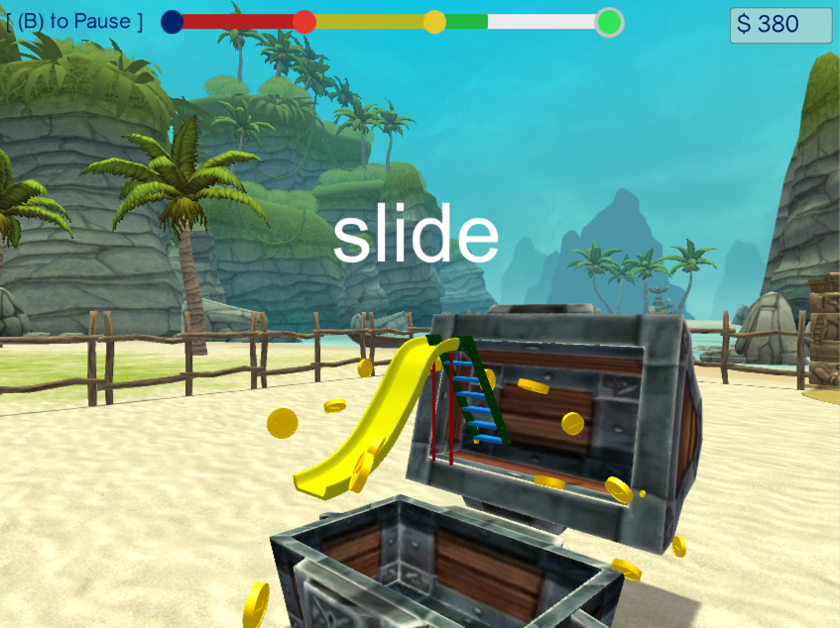

Time Bonus
Navigation Time (s) | Point Bonus
< 22 | +30
< 37 | +20
< 52 | +10
> 52 | +0

Once the player has collected all treasure chests, we move the subject to a higher, perspective view of the field for the retrieval portion of the task. This takes between 1.5 and 3.75 seconds, depending on distance. Similar to the starting position, this tower position could be at either end of the field, regardless of where the subject started, ended, or traveled. Then they are shown a short, distraction task, which is a mini­-game, where there are three, rearranging boxes. In one of the boxes, we place a coin, and at the end of the rearranging, the subject must choose the correct box in order to get a score bonus of +200 points. Thus, they must follow the correct box throughout the rearranging process, or they will receive no bonus. This is implemented to get rid of the recency effect and emphasize episodic memory over rehearsed, short-term memory. The entire distractor task takes 3.5 seconds plus however long it takes for the subject to choose a box.

Box Swap Mini-Game Timing
Box Event | Time (s)
Boxes hover to demonstrate coin position | 0.75
Boxes lowered to ground position | 0.75
Boxes Swap 4x | 0.5 * 4 swaps = 2
Player chooses a box | player dependent
Boxes raise up again, show coin | 0.75
Pause to see coin | 0.75

Distractor Task: Box Swap Mini-Game
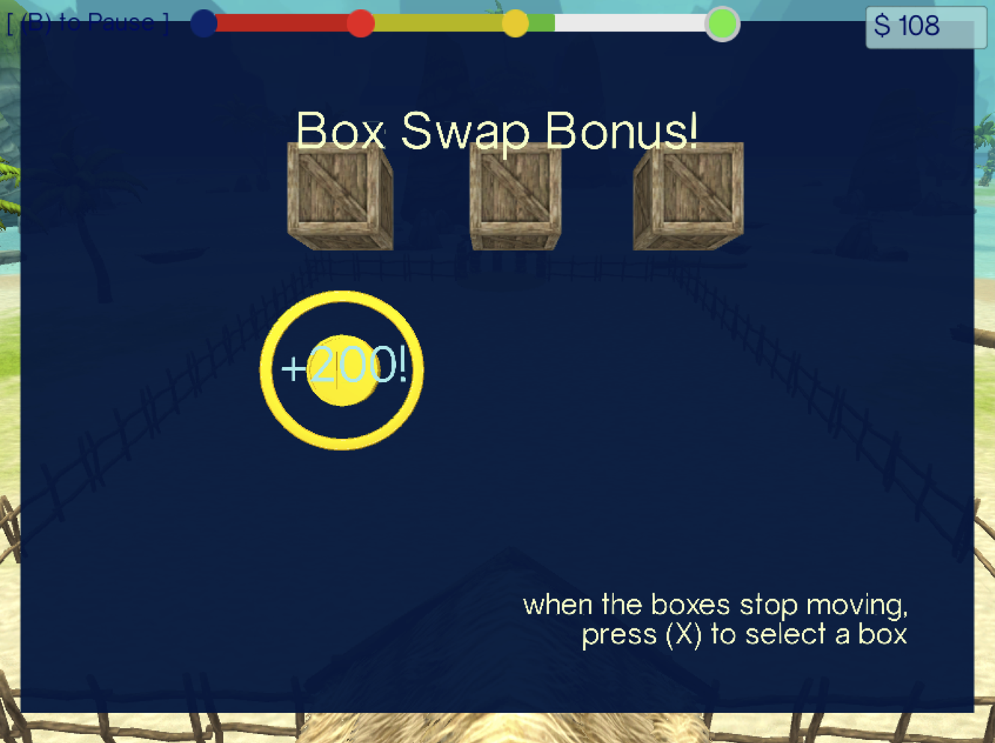

After the distractor game, we enter the recall phase. The player will be asked to recall each object that they saw earlier in the trial in a random order. Before each object is presented, there is a pause (jitter) between 0 and 0.2 seconds. Then, for each object (presented visually, with the same particles and sound as when it was revealed in the treasure chest), we ask the subject if they remember the object's location (yes / maybe / no), and then they must choose the location with a circle that they can move around the field.

The selection circle radius is 13 units, which we chose based on piloting as a sensible balance between making the task appropriately difficult and still ensuring that it is fun and engaging for the patient. By our calculations, getting an object’s location correct by random chance is just below 11%.

Object Selection
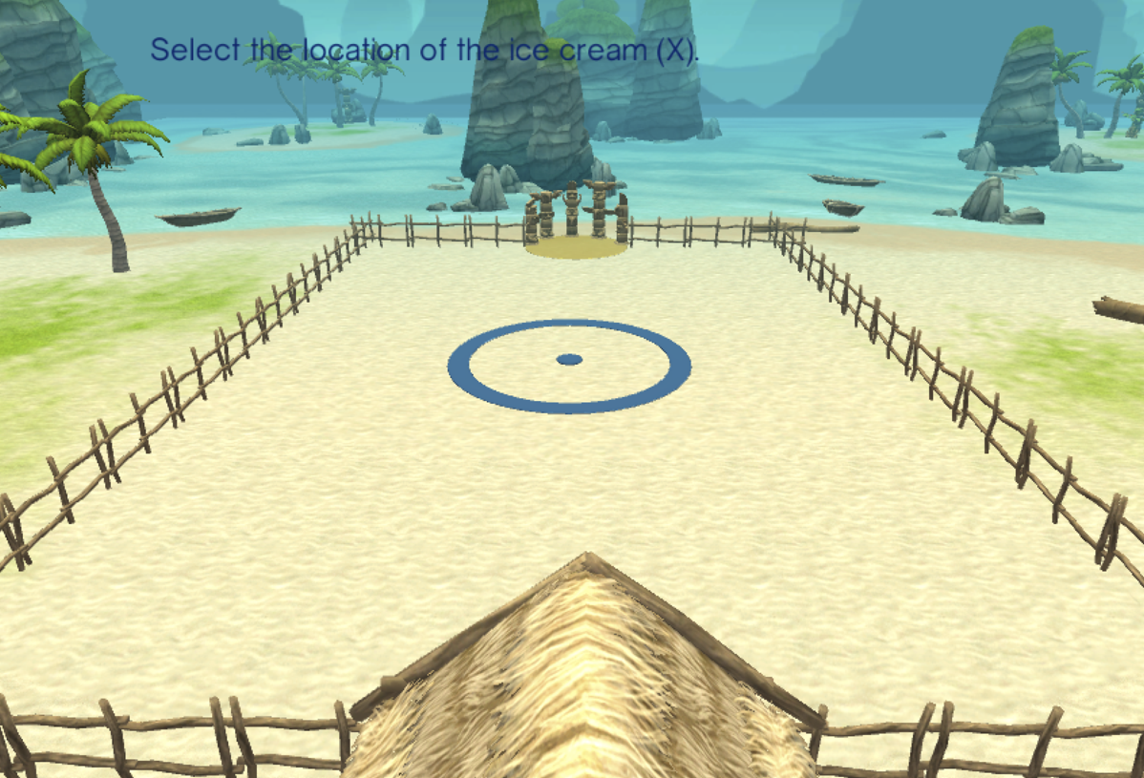

Only after all object locations have been selected do we show the player how close their guesses were to each object, and give them points. In order to do this, immediately after the last object has been recalled, a coconut is thrown for each object from the tower to each chosen position, consecutively. The coconut is thrown for 1.2 seconds and is followed by a 0.5 second pause before the next one is thrown. When the coconut lands, a circle will show up on the ground around the chosen position in red or green, depending on if the object landed within that radius. The radius is the same radius as the circle used for recall. A line is then drawn from the center of the chosen radius to the object location, and the object becomes visible on the field with the points scored hovering above it. The player must press [X] to continue, and they are shown a screen recapping the points they scored for each object, the time bonus, and for the box swap game. Then, the player can press [X] to continue to the next trial, and the timer bar is reset. After every 8 trials, we show them another screen demonstrating their block scores thus far and how many blocks they have left. Their overall score gets reset when they press [X] to continue to the next block.

Scoring Table
 | Not Remembered | Remembered, Not Sure | Remembered, Sure
Correct | +50 | +100 | -50
Incorrect | +0 | +200 | -350

Feedback Screen
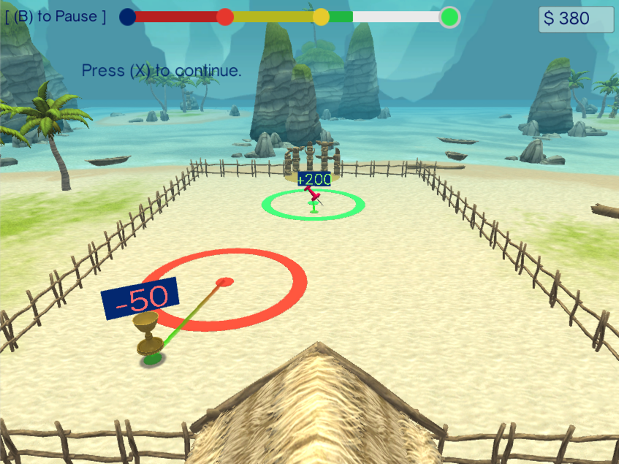

Score Summary Screen
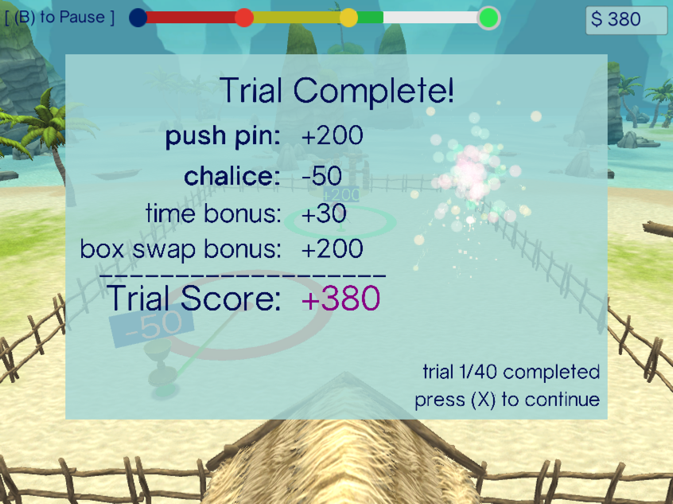

Trial Generation

As mentioned before, there are 40 trials distributed across 5 blocks of 8 trials each. In each block, there are four 3-object trials and four 2-object trials. The trials are generated before the player enters the game by determining the avatar start position, the tower position, and the positions of all of the chests, empty and full. Additionally the trials are counter-balanced. Thus, we create ten original 2-object trials and ten original 3-object trials. Then, for each of these original trials, a second is generated with the opposite starting position, tower position, and reflected treasure chest positions. We then end up with 40 trials total. Next, for each block of 8 trials, we randomly pick four 2-object trials and four 3-object trials out of all generated trials, original and counter-balanced, so that the counter-balancing occurs across the entire set of 40 trials.

Within each generated trial, the player’s starting end and tower end are determined randomly. The positions of the treasure chests are chosen randomly within the walls of the field and within a specified buffer -- the diameter of the location selector (20 units). Once a random position has been chosen, we check to see if it is within the bounds of any other (already generated) chest in that trial. If it overlaps, we try again, for a maximum of 15 times so that we do not stall the game. Thus, while possible that two chests could overlap, it is extremely unlikely. Once all chest positions have been generated, we order them by ‘next-closest’. Thus, the first chest in the order is the one closest to the player’s start position, and the next in the order is the closest chest to the first chest, and so on. Once chest position and ordering is complete, we randomly choose any 2 or 3 of the chests to be an object-containing chest, based on if we are generating a 2 or 3-object trial.

Trial Predictability

Depending on which chests contain special objects, sometimes the player can figure out if the next treasure chest will or will not contain an object. For example, if the player saw no items in the first two treasure chest, it becomes obvious that the last two chests must contain items, giving them a longer period of time to encode the location of the remaining two chests. Similarly, if the first three chests are filled, it is obvious that the last one is empty, as there can be no more than three objects. To avoid this, we have excluded these predictable treasure chest configurations without informing the player. Since we assume that the player is not keeping track of how many 2-object and 3-object trials they have completed, each object encountered should be a surprise.

Possible 2-Object Configurations (NP - not predictable trial, P - predictable trial)

1 | 1 | 0 | 0 | NP
1 | 0 | 1 | 0 | NP
0 | 1 | 1 | 0 | NP
0 | 0 | 1 | 1 | P
0 | 1 | 0 | 1 | P
1 | 0 | 0 | 1 | P

Possible 3-Object Configurations (NP - not predictable trial, P - predictable trial)

1 | 1 | 0 | 1 | NP
1 | 0 | 1 | 1 | NP
0 | 1 | 1 | 1 | NP
1 | 1 | 1 | 0 | P

